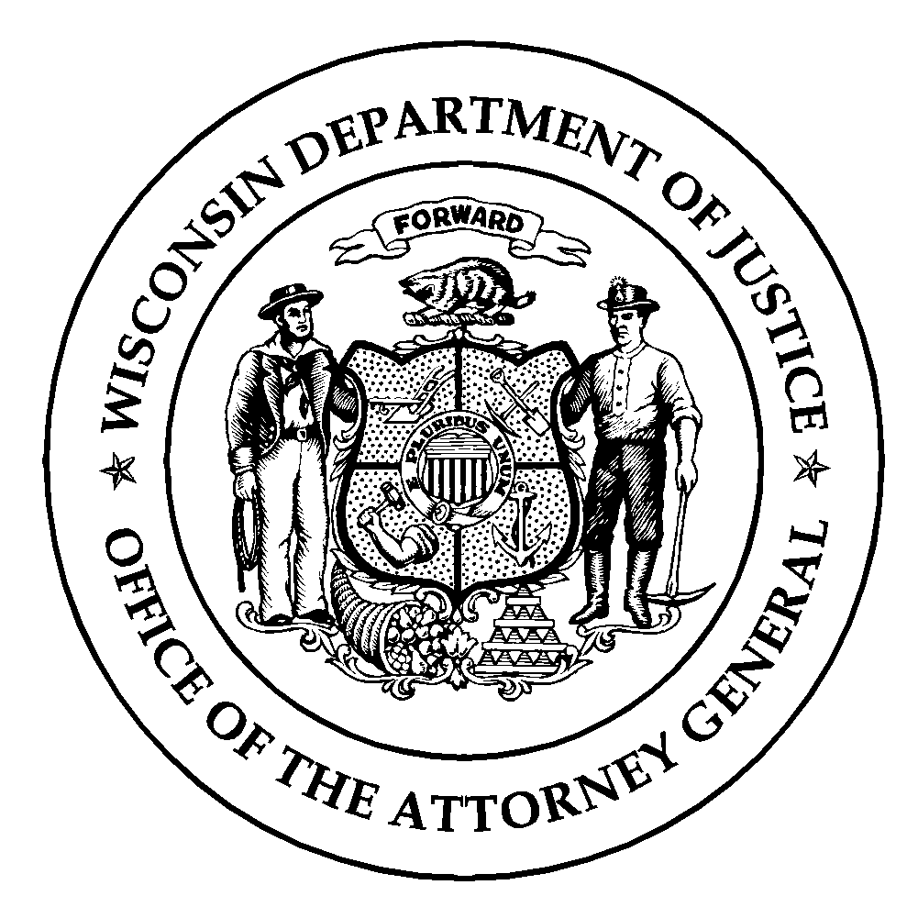Wisconsin Department of Justice
Law Enforcement Standards Board
DJ-LE-336, Rev. 10/14
www.wilenet.org

INSTRUCTOR TRAINING COURSE APPLICATION
LESB-APPROVED TOPIC-SPECIFIC INSTRUCTOR COURSES

To be eligible for instructor certification with the Law Enforcement Standards Board (LESB) in any of the following topics: Defensive & Arrest Tactics (DAAT), Emergency Vehicle Operation & Control (EVOC), Firearms, Principles of Subject Control (POSC), Professional Communication Skills (PCS), Standardized Field Sobriety Testing (SFST) or Vehicle Contacts, a LESB-approved Topic-Specific Instructor Course must be completed.

This form must be signed and dated by both the applicant and the applicant’s employer (agency administrator), and returned to the training school in advance of admission to a LESB-approved Topic-Specific Instructor Course.

Last Name | First Name | Middle Initial
SSN (last 4 only) | Employer

Instructor Development Course (Check the box that applies to you)

Exempt - I am currently a LESB-certified instructor seeking additional certification in a new topic area.
(Attach a copy of your Acadis Training History Report showing current instructor certification)

I completed the 32-Hour Criminal Justice Instructor Development Course (CJ-IDC) within the past two (2) years.

Date Completed:
(Attach a copy of your CJ-IDC Course Completion Certificate)

None of the above. If none of the above apply, you are not eligible to take part in a LESB-approved Topic Specific Instructor Course.

Occupational & Educational Experience (Check all of the boxes that apply to you)

I have acquired 3 years of full-time, or at least 6,000 hours occupational experience as a certified law enforcement officer and have attained an associate degree or at least 60 associate degree level or higher college credits and wish to complete one of the following LESB-approved Topic Specific Instructor Courses: DAAT, EVOC, Firearms, PCS, SFST, or Vehicle Contacts.

I have acquired 3 years of full-time, or at least 6,000 hours occupational experience as a certified jail officer and have attained an associate degree or at least 60 associate degree level or higher college credits and wish to complete the LESB-approved PCS Instructor Course.

I have acquired at least 3 years of full-time, or at least 6,000 hours occupational experience as a certified jail officer or secure juvenile detention officer and have a high school degree or hold an equivalent diploma and wish to complete the LESB-approved POSC Instructor Course.

None of above. If none of the above apply, you are not eligible to take part in a LESB-approved Topic Specific Instructor Course.

I affirm that the information provided above is both true and accurate.

Applicant’s Signature Date

Agency Administrator’s Signature Date

